BIO-366; Original paper III; Pathania et al. (2002). Cell 109: 425-436.
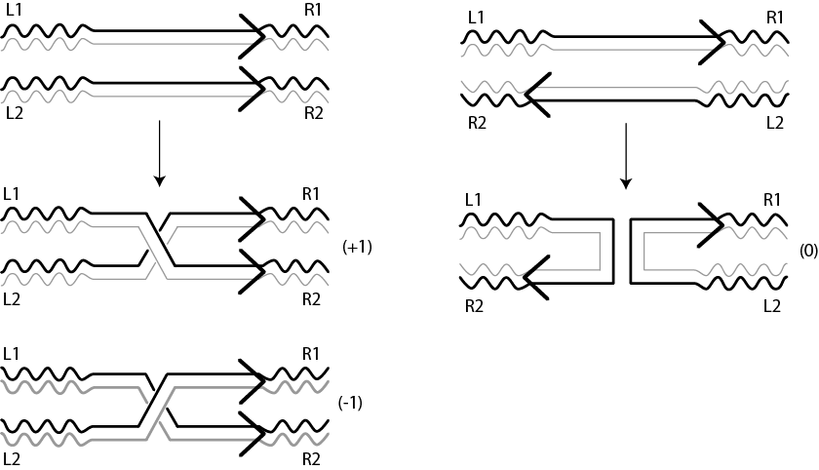
What should we know as background to understand this paper?
- Site-specific recombinases are enzymes that recognize specific target DNA sites and cut and join them to yield reciprocally recombinant products. We will have discussed this topic in class. In the example shown here, the target sites, shown as arrows are present on two DNA duplexes, L1-R1 and L2-R2. The result of DNA is the formation of the recombinant duplexes, L1R2 and L2-R1. L and R refer to the left right orientation of the DNA duplexes.

- The simple members of the tyrosine recombinase family, Flp and Cre can act on linear, supercoiled circular and nicked circular DNA molecules. They can also act on sites located on separate molecules. When the sites are on the same molecule, the reaction is called intra-molecualr; when they are on different molecules, the reaction is called intermolecular.

- When the target sites are present on a circular molecule, the result of the recombination reaction depends on whether the sites are in head-to-head (inverted) or head to tail (direct0 orientation.

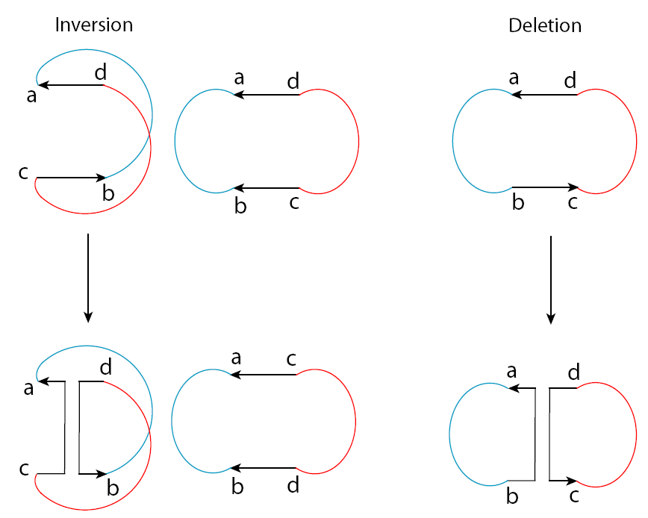
When the sites are head-to-head, recombination will invert the two DNA segments separated by the recombination sites relative to each other. In the diagram shown here, the two DNA segments are distinguished by coloring them red and blue, respectively. We can consider the DNA circle being split into two separate domains by the recombination sites, a red domain and a blue domain. If you follow the DNA contour, you can readily see the inversion: ‘a-b-c-d’ in the parent and ‘a-b-d-c’.
When the sites are head-to tail, recombination will separate the parent circles into daughter circles. The reaction is called an excision reaction or a resolution reaction or a deletion reaction. The result is that the red and blue domains are separated into individual circles.

- Note that proteins are small in size compared to DNA molecules that are larger. Recombinase proteins cannot sense the global orientation of sites on DNA molecules (unless they can track along DNA by burning fuel, ATP). Tyrosine recombianses do not utilize energy for recombination. They see their target sites locally and recombine them. The final result is DNA inverstion for head-to-head sites, DNA deletion for head-to-tail sites.

- When the recombination reaction occurs with the sites placed in the same plane (planar synapse*), there are two ways in which sites can be oriented: either parallel or antiparallel. This is shown in the figure below. When the recombination reaction is completed from a parallel synapse, there is a DNA crossing or node created at the site of exchange. When the reactions completed from an antiparallel synapse, there is no DNA crossing or node formed at the site of exchange. * A synapse is the reaction complex containing the recombinase and the DNA sites.

Note: there is strong evidence that the tyrosine recombinases carry out recombination with the target sites arranged in one plane.

Parallel synapse and recombination
Antiparallel synapse and recombination
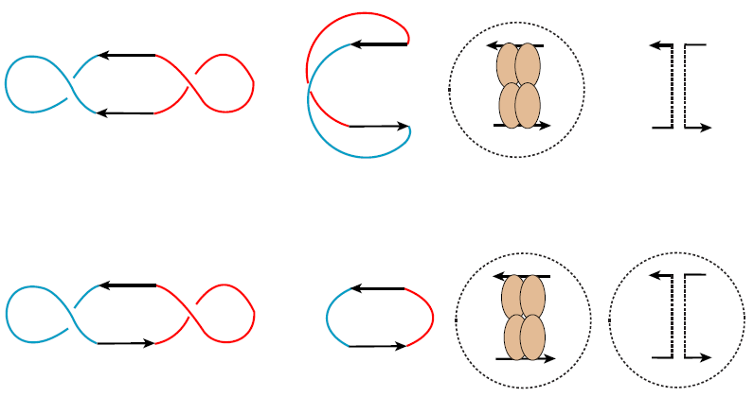
- DNA supercoils can be formed within a domain (blue over blue or red over red crossings) or between domains (blue over red or red over blue): intra-domainal crossings or inter-domainal crossings. As we shall see, inter-domainal crossings can be trapped as knot crossings or catenane (link) crossings in DNA. Intra-domainal crossings are simple supercoils. The knot and catenane crossings are useful in understanding the DNA arrangement within a DNA-protein assembly or the mechanism of DNA exchange reactions. (Don’t be alarmed; we will discuss these aspects).
In the figure, the crossings in the left molecule are intra-domainal supercoils; the crossing in the right molecule is inter-domainal.

If you follow the DNA path carefully, you will note that the molecule at the left and the right have the recombination target sites in the head-to-head orientation. We can assume that these two molecules are the same plasmid substrate. I did not draw the intra-domainal supercoils (red x red or blue x blue) in the right molecule. You will see that when there is no red x blue crossing (left molecule), the head-to-head sites are in parallel orientation. When I added one crossing (right molecule), the same sites are in antiparallel orientation. If I introduce two red x blue crossings, the sites will be parallel; if I add three, they will be anti-parallel. Or if there are 0, 2, 4, 6---- (even) number of crossings between the red and blue domains, head-to-head sites arrange themselves in parallel fashion. If there are 1, 3, 5---- (odd) number of crossings between the red and blue domains, the sites orient in the antiparallel fashion.
See below, for further explanation.

- Recombinase enzymes are particular about the geometry of the sites within the recombination synapse. For a particular enzyme, this may be parallel, for another enzyme antiparallel. The same enzyme cannot use both the parallel and antiparallel geometries for reaction. Unless there is some perfect symmetry within the enzyme, it is almost impossible that both types of geometries will place the active site and the catalytic residues in the right configuration with respect to the phosphodiester bonds to be broken and joined. This is what I meant earlier by the ‘small enzyme protein’ seeing its target sites within the ‘large DNA substrate’ locally.

Imagine a recombinase that arranges the sites in antiparallel fashion to perform recombination. Let us assume that this enzyme (like Flp or Cre) can act on head-to-head sites or head-to-tail sites. It simply acts on sites locally, without knowing whether the sites are head-to-head or head-to-tail. When the sites are head-to-head, the result is inversion. When the sites are head-to-tail, the result is deletion. Because the recombinase gives the inversion reaction and the deletion reaction, the experimenter knows that the enzyme is not particular about the orientation of the sites.
How will this enzyme arrange the antiparallel geometry on head-to head sites? As we saw above, it has to introduce at least on red x blue (inter-domainal crossing). Or it could introduce three crossings, or five crossings or an odd number of crossings. When it completes recombination, the red DNA domain is inverted with respect to the blue domain. See diagram below.

DNA inversion from antiparallel synapse:
In the top panel of the figure, the four ovals represent the recombinase subunits. They cut the DNA, and rejoin them as indicated at the extreme right. In the bottom panel, the result of a recombination event on head-to-head sites is illustrated.

How will the enzyme arrange antiparallel geometry on head-to-tail sites? It will have to introduce no or 0 red x blue crossing or 2, 4, 6, 8 or even number of such crossings. Following recombination, the red and blue domains are resolved into separate circles. The two circles may be unlinked or linked (catenated).

DNA deletion from antiparallel synapse

